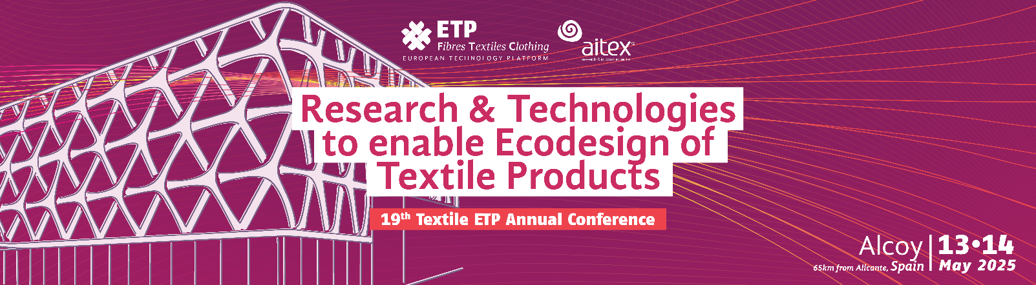

**HOTEL RECONQUISTA RESERVATION FORM**

19th TEXTILE ETP ANNUAL CONFERENCE | 13th – 14 MAY 2025 ALCOY

COMPANY:

PARTICIPANT:

Name and surname:

Address:

e-mail:   
  
 Phone:

YOUR STAY:

Number of nights:

Arrival date:

Departure date:

ROOM BOOKING INFORMATION –  
**1.-To confirm the reservation, you must fill in the authorization with the bank card number, expiration date and CVV and send it along with the reservation form.**

**2.-** **On March 31st, we will charge the total amount of the reservation to the bank card.**

**3.-** **If you cancel your booking before 5 May, you will be refunded 100% of the booking amount.**

**After May 5, it cannot be canceled.**

ACCOMODATION TYPES

**ONLY ROOM:**

**Double Classic room for single use: 49 EUR**

**Double Classic room: 55 EUR**

*Price per night and room. VAT Included.

**WITH BREAKFAST INCLUDED:**

**Double Classic room for single use: 56,50 EUR**

**Double Classic room: 70 EUR**

*Price per night and room. VAT Included.

GENERAL INFORMATION - **special eating habits, allergies, intolerances**